Lab report 4: Igneous Rocks
YOUR NAME HERE
YOUR E-MAIL HERE
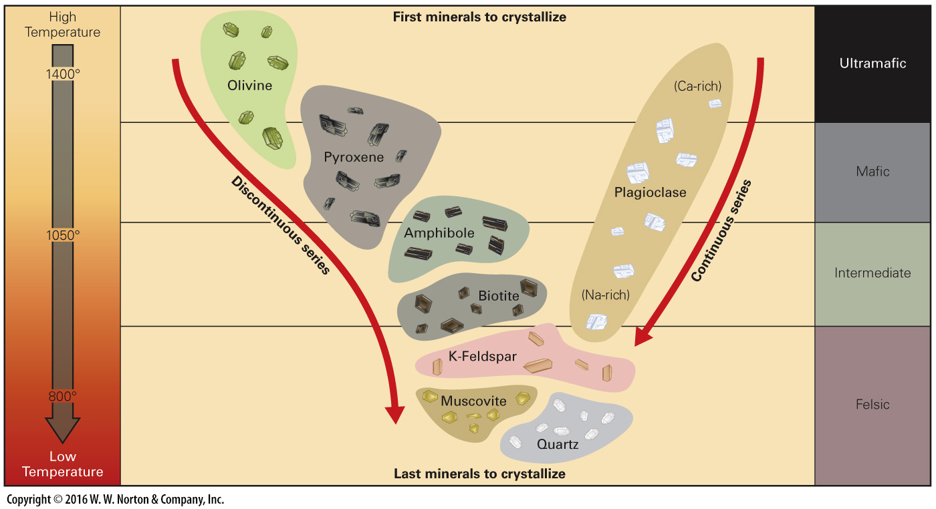
Use the Bowens reaction series to think through the following problems:
Your friend is in ceramics class, and his pottery furnace keeps getting so hot that his clay (Which he says has a lot of feldspar in it) keeps sagging because the feldspar is melting too much. He thinks that if he replaced the feldspar in his recipe with something that won’t melt, he might have better luck. He asks you if you might have any ideas on what rocks to use, since he remembers that you talked so much about that geology class you took.

4.1 If the feldspar in your friend’s clay is melting, at what temperature do you think his furnace reaches? (0.5)

4.2 Explain how he could fix his clay; what other minerals could he add instead of feldspar? (1)

Your friend comes back and says that he couldn’t find any of those minerals on the shelf at the pottery store, but he read a DIY on how to make ceramic materials, so he is just going to go find the minerals he needs and grind them up and mix them in. You explain to him that it’s not very common to just find raw minerals, usually they are in rocks and it’s going to be a lot of work, but he still seems determined.

4.3 In general, what colored igneous rocks should he be looking for? (0.5)

A group of agriculture economists recently returned from a trip where they were studying the types of plants that grew in different European mountains. The noticed that the rocks in the French Pyrenees (the range of mountains that separates Spain from France) changed color so they collected 8 samples of rocks as they walked across. Using an electron microprobe, the average oxide weight percent composition of each rock was determined and reported below in the table.
 | SiO2 | FeO | MgO | CaO | Na2O | K2O | Other
Sample 1 | 48.6 | 10.31 | 6.72 | 10.65 | 2.02 | 0.69 | 21.7
Sample 2 | 52.18 | 8.31 | 5.42 | 7.63 | 2.72 | 1.2 | 23.74
Sample 3 | 56.21 | 7.34 | 4.02 | 9.77 | 0.63 | 3.75 | 22.03
Sample 4 | 62.98 | 4.05 | 2.28 | 4.87 | 1.7 | 3.97 | 24.12
Sample 5 | 69.84 | 2.32 | 1.41 | 3.08 | 2.61 | 4.31 | 20.74
Sample 6 | 72.15 | 1.26 | 0.41 | 2.22 | 0.78 | 6.43 | 23.18
Sample 7 | 74.12 | 1.21 | 0.16 | 1.22 | 0.72 | 7.82 | 22.57
Sample 8 | 73.12 | 1.51 | 0.23 | 1.58 | 1.23 | 5.31 | 22.33
(The original saddleback lab had you do this by hand! I typed them up here in case you want to use a computer to speed things along)

4.4 Plot (Graph) each of the metal oxides against Silica (SiO2) (1)
HINT: Your graph should look something like this
The silicon percent should be on the left going up (Y) and the other metals all on the flat side (X)

4.5 Which of these elements increase as silica (SiO2) increases, and which of them decrease? (1)

4.6 According to the Bowens reaction series, which of these rocks might have formed first, and which of them might have formed last? (1)

