Lab Notes 2:

Lab Report 2:
Your Name:
Your email:

1.1 What is the most useful test you can perform on a mineral, and why? (0.5)

1.2 What minerals in our box did you find easiest to confuse? (0.5)

1.3 What tests are most useful for separating apart the easy to confuse minerals? (0.5)

1.4 Explain why Bauxite a rock in your mineral box, is out of place? (0.5)

1.5 Paste in the electron probe micro analysis data for the 2 samples you probed, and label each one with its correct mineral name: (1)

1.6 Did you pick good settings for each of the 5 spectrometers? If not, what might you do differently? (0.5)

1.7 Select one of the minerals that you have electron micro analysis data on, and convert it from atomic fraction to a chemical formula. (1)

You are working off the coast of Papua New Guinea for a seabed exploration mining company The Company is using robotic machines to find hydrothermal vents on the sea floor and mine them if they contain high concentrations of gold. The mining machine is equipped with a RAMAN spectrometer and X-Ray diffractometer as discussed in class, and it is sending back scans it collected:

Sample 1 Raman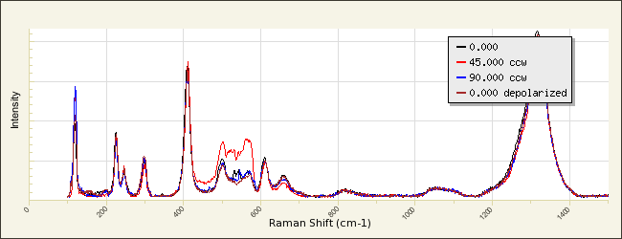

Sample 1 X-Ray diffraction
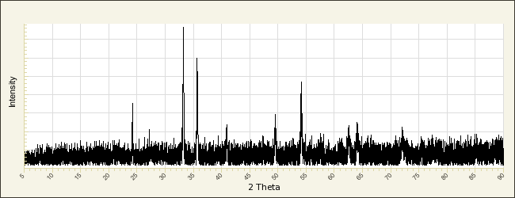

Sample 2 Raman
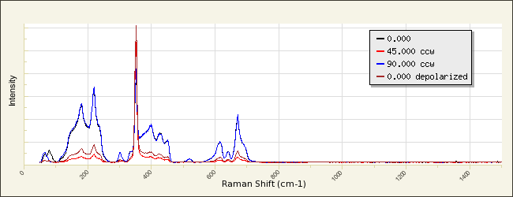

Sample 2 X-Ray diffraction
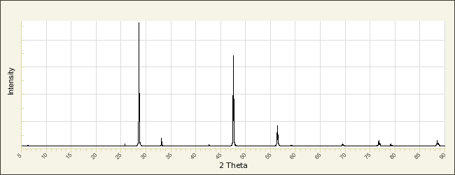
Head to the RRUFF database http://rruff.info/ and search through the database to see if you can match the spectra from above to one of the sample (A close match is fine, it does not have to be the exact same spectra, but the peaks should be in about the same spots). HINT: The hydrothermal vents that you are working with do not produce silicate rocks, so we can rule all of those out. Also the minerals halite and fluorite would dissolve in seawater, so we can also rule them out. Lastly one of your co-workers told you that the conditions are not right to form graphite, magnetite, or pure sulfur.

1.8 Which two minerals do you think you found? (0.5)

1.9 If either of these minerals contain sulfides and a transition metal, it’s a good sign that this area may have a gold vein. Based on your two spectra, is this a good place to start mining? (0.5)

