Lab report 6:
YOUR NAME HERE:
YOUR E-MAIL HERE:
ONLY 6.1 is done with your partner.
6.1 Describe 8 sedimentary rocks. Include a photo (labeled!), rock name, class, clast/grain size, note on composition, angularity, sphericity, sorting, cement, and porosity. BE DESCRIPTIVE! (2 pts).
 | Rock Name | Class | Clast size | Composition | Angularity | Sphericity | Sorting | Porosity | Cement
1
2
3
4
5
6
7
8

6.2 Rank the 4 sedimentary rock beds from highest energy to lowest energy based on their clast size (1).
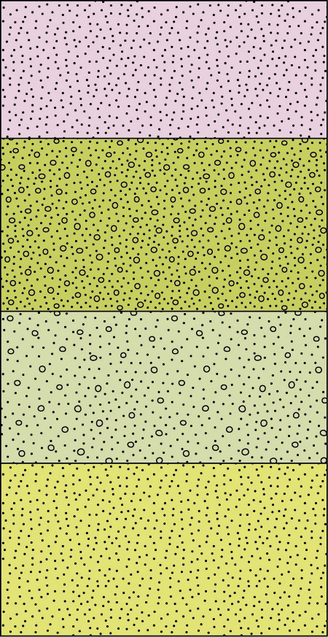

6.3 In the following microscope slide, identify a quartz sand grain (the white objects) with each of the following (1): high sphericity, low angularity
low sphericity, low angularity
high sphericity, high angularity
low sphericity, high angularity
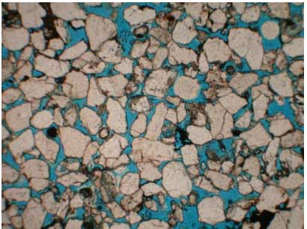

6.4 Choose a class of rock for each of the following (1):
A rock formed from an evaporating sulfuric acid pool.
A rock formed in a dessert from broken up rocks which have slid down hill.
A rock formed in a highly vegetated swamp.
A rock formed from otoliths created in a warm ocean.

