Lab report 5:
Due Feb 21
YOUR NAME HERE:
YOUR E-MAIL HERE:

The goal of this lab is to become comfortable with maps.
- Understand scale.
- Understand two coordinate systems: latitude-longitude and UTM.
- Understand locating yourself using those coordinate systems.
- Use a map to do something useful.

MAP 1 (Scale)
4.1 One inch on the map corresponds to how many inches in the real world? (0.25)
4.2 One cm on the map corresponds to how many cm in the real world? (0.25)
4.3 One smoot on the map corresponds to how many smoots in the real world? (0.25)
4.4 How long is the bridge over Nolan’s creek? (0.25)

MAP 2 (Scale continued)
4.5 One inch on the map corresponds to how many miles in the real world? (0.25)
4.6 One cm on the map corresponds to how many km in the real world? (0.25)
4.7 One cm on the map corresponds to how many miles in the real world? (0.25)
4.8 2.54 cm on the map (one inch) corresponds to how many miles in the real world? (0.25)

North
4.9 You are standing at Harrison lookout, and line up your compass so when you are looking at Perez falls, and line up the S with your feet, and the N with the falls, the compass arrow points as it does in the picture. Which direction is North on the map? (0.5)

MAP 3 (UTM coordinates)
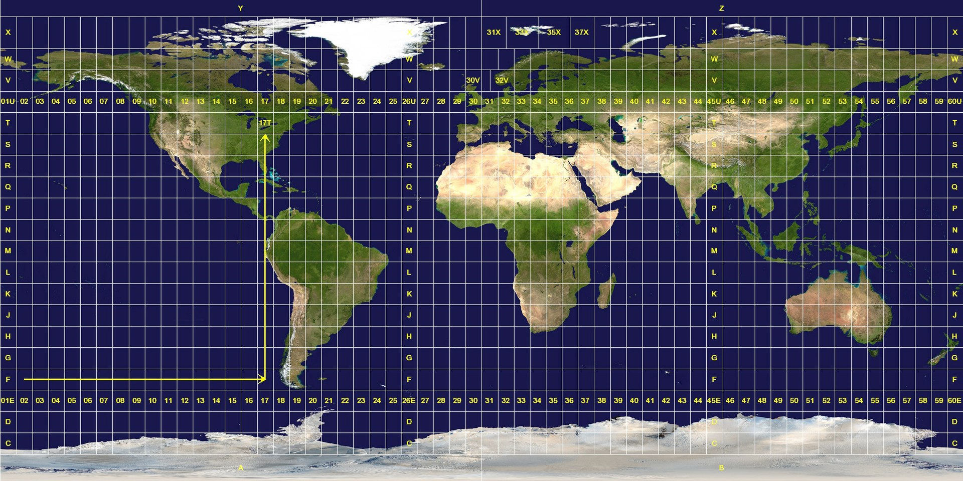
Big version online: http://Moderngeology.com/labs/UTM.jpg
4.10 Which UTM zone and letter covers most of Florida? (0.25)
4.11 Which UTM zone and letter covers most of Lake Michigan? (0.25)
4.12 What continent is located at Zone 34 P? (0.25)
4.13 The units on UTM coordinates are always in what? (0.25)

Degrees minuets seconds
4.14 In the above coordinate: (0.25)
A) How many degrees North?
B) How many seconds West?
C) How many minuets North?
https://www.uwgb.edu/dutchs/UsefulData/ConvertUTMNoOZ.HTM
4.15 Convert the Deg Min Sec to UTM (0.25)
4.16 What is different between the Standard and NATO version of UTM? (0.25)
https://www.geoplaner.com/
4.17 Check your UTM work! Where did end up? (0.25)
(Hint: if its China, think about problem 4.17)
4.18 Explain how UTM, and degrees minuets seconds captures being east or west of the prime meridian. (0.5)

Map 4 (Latitude longitude)

Using Map 4, answer the following lat long questions
4.19 Which color lines are latitude? (0.25 total)
4.20 Which color lines represent longitude? (0.25 total)
4.21 What is the location of the black 12 pointed star? (Just like for UTM please report it Latitude and then Longitude) (0.25 total)

Map 5 (declination and units)
4.22 What is the magnetic declination on this map? (0.25 total)
4.23 How old is this map? (0.25 total)
4.24 How likely is it that this magnetic declination is still accurate? (0.25 total)
4.25 Check online for a more recent declination. (0.5 total)
(HINT: This website will work, but it needs Deg and a fraction for the min and sec. Don’t ask me why! Most of the NOAA maps are in UTM https://www.ngdc.noaa.gov/geomag-web/ )
4.25 How many geologic units are located on the map? (0.25 total)
4.26 Which geologic unit is the oldest? And which is the youngest? (0.25 total)
4.27 An inch on the map equals how many feet in the real world? (0.25 total)
4.28 You just hiked to the top of Schultz peak, located at the top of an orange granite outcrop. What is the UTM location of where you are standing? (0.25 total)
4.29 You are thinking about selling your gravel claim located at UTM 11T 2900E 651000N, and have listed it on e-bay. A potential buyer asks “How wide is it in feet?” Using the map, estimate how wide the big gravel claim is. (0.5 total)

