The outside geology report (you will give your project A unique Name).
By Ryan J McCarty
rmccarty@saddleback.edu

Summary: In this section, you will present the reader with no less than 3, and no more than 7, sentences that given them a good idea of what you are going to talk about and how important it is that they bother to read your report. Your report will discuss something you found outside in the real world that is related to geology. First you will give some background to the area you were in when you found your geology (geologically speaking!), then you will describe what you found, and lastly you will hypothesize how your geology was formed. Another important goal for this project is to give everyone some exposure to how scientists present their ideas using text and visuals together to tell a story. Lastly BE SAFE. Do not do anything risky to complete this project, and whenever using your cellphone or posing for picture be sure that you are thinking about safe first.

Introduction
In the introduction, you will tell me a little bit about the background that might be important to know before reading your report. A pretty important part is explaining where you were, so be sure to tell the reader.

Remember to cite and references that help you put together your story. If you referenced our text book it would look something like this (Marshak, 2016). If you looked up a Wikipedia article to learn about the geology in Big Bear (Contributors, 2017), you would cite Wikipedia. We will be using the Geological Society of America citation style for this assignment. A full explanation on how to use the GSA style is given online (“GSA Reference Guidelines and Examples,” 2017), and most reference managers can look up the style for you as well.

You will note that this is for a GEOLOGY class, and thus presenting your evidence and your geologic ideas is far more important than any fancy writing. This is not an English class paper! Spend your time on communicating your ideas instead of on grammar, complex words, and style. Think simple and clear.

Main facts and points
In this section you will present all of what you geologically saw and found. The geology MUST be in place, this means that you are not looking at geology that has been relocated by humans or recent erosion. A landscaping rock in a park is not usually “in place”. A cliff face along the beach IS in place, since it was moved by natural forces.


Figure 1. Title of your figure. A few sentences describing what is important in your figure. For example this figure has Ryan McCarty in front of a geology assignment that he found. Use of “Photoshop” or photo editing is not allowed on this photograph. Please note how the photograph has 1) the geologic feature (the assignment) 2) my person, and 3) the date.

Take the necessary selfie-date photograph (Figure 1), as well as any other photographs you need to tell your story. A full credit assignment likely has 1 selfie-date photograph, 1-3 photographs from far away and 1-3 photographs of the close up rocks. (You won’t need more than 7 photos, and even that may be overkill.) In your text, you need to call out every figure that you include, such as figure 2, which is a good example of a close up photo.

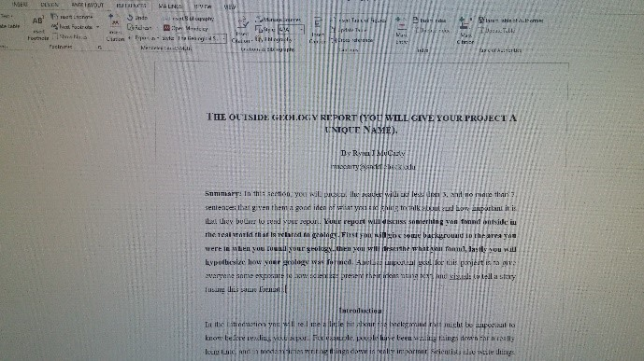
Figure 2. A close up photo of a geology assignment. The assignment was made up of words, and appears to explain how to do this assignment. The text size looks like it is about 12 point font, and is written in a black color.

Discussion
In the discussion section you draw together your argument and connect the dots for the reader. In this case, you are going to explain why you think you are seeing what you are seeing. Then you will explain how you think the geology you saw was formed. These do not have to be completely separate paragraphs, and may need to be intertwined to tell your story most effectively. Try as best as you can to draw in as many parts of our class that you think play an important part in the geology you saw (for instance, depositional environments, plate tectonics, minerals, rock cycle, geologic ages, structural geology, etc).

You must have at least 2 drawings of the geology. They must be done by you, but can be done in crayon, on the computer, with pencil, or anything else that makes it clear to the reader. I recommend having color as well as labels in the drawing.

Why you think you are seeing what you are seeing: For example if you think you saw a lava flow on top of sedimentary rocks, you might explain how you found sandstone underneath a whole bunch of basalt. Then explain how the law of superposition states that the older rock will be the one on the bottom.

Figure 4. A drawing done by me which is about some geology. Notice how the figure has labels explaining what I tried to draw, and some color to make it interesting.

How you think the geology you saw was formed: For example, if you think you saw a lava flow on top of sedimentary rocks, you should explain all the steps you know are necessary to create that environment: first how the sandstone must have been made in a water environment, since you saw shells in it, and not windblown cross beds, and then how you know that the next lava step probably was not underwater, so the sand stone must have moved out of the water. Since you were in California, you think it was caused by plate tectonics and the subducting plate under California causing uplift. Once on the surface, a lava flow must have covered the sandstone. You think the lava flowed across because it’s a mafic rock, which comes from very runny lava (non-viscous), and it was aphaeretic, indicating that it must have cooled off very fast to get the small grain sizes.

Figure 5. A drawing which explains the steps that might have created your geology. Notice how the figure has labels explaining the rocks, and putting each one in its own step. In this section I should explain each step. For example (a) formation of the sandstone unit in an underwater setting near a costal beach.

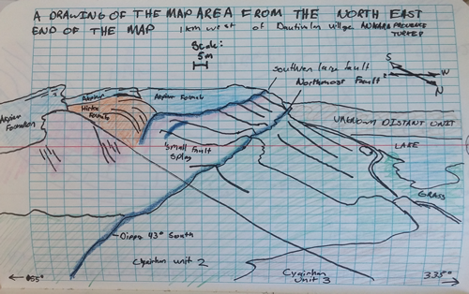
Figure 6. Another example drawing done by me which is about some geology. Notice how the figure has labels explaining what I tried to draw and some color to make it interesting.

Conclusion
In 1-3 sentences, restate the key facts of the history of the geology you found. For this assignment’s sake, the key point is following the standard scientific writing format while incorporating visuals with written text.

References
Contributors, W., 2017, San Bernardino Mountains: Wikipedia, The Free Encyclopedia, https://en.wikipedia.org/w/index.php?title=San_Bernardino_Mountains&oldid=791868539 (accessed October 2017).
GSA Reference Guidelines and Examples, 2017, Geological Society of America, p. 3, https://www.geosociety.org/documents/gsa/pubs/GSA_RefGuide_Examples.pdf (accessed October 2017).
Marshak, S., 2016, Essentials of Geology: New York, W. W. Norton & Company, INC, 648 p., http://books.wwnorton.com/books/webad-detail-editions.aspx?id=4294969500.

At the end of your document you must have an outline:
1 outline should be included at the end of the document. (If this is not included at the end of the document, it will not be graded). YOU MUST HAVE AN OUTLINE. I strongly strongly strongly strongly encourage you to write the outline first…. and then write the paper second. It really will save you time, and make things so much clearer for the person who gives you grades (which in my opinion is a really good idea).

Here is a checklist/points break down for how you will be graded
Check list | Value
Outline after the references | yes/no *
Title | yes/no *
Author name | yes/no *
Author e-mail | yes/no *
Selfie photo with a date | yes/no *
Two drawings done by you which are used to explain your story | yes/no *
Summary which summarizes the main points | 5
Introduction which give background important to the argument | 5
Presentation of the geology that you found | 25
Discussion about the origin of the geology that you found | 15
4 references (at a minimum), including: | 5
2 academic references not counting our text book | 5
All references listed in the reference section | 5
Correct formatting used in the reference section | 5
Word count between 800 and 1500 words | 5
Total points | 60
* If you are missing any of the yes/no items, the most you will be able to earn is 30 points total

