Google Project
This is due on March 5th (2018-03-05)
Submit online at: https://moderngeology.com/homework
or e-mail to rmccarty@saddleback.edu

Getting started
You will need to go to a computer with internet access and the internet browser google chrome. (I think everything can be done on a phone, but I do NOT recommend it).
Make sure there is a good internet connection. If your internet at home is not very good, I recommend using a campus computer for a faster experience.
You MUST have google chrome. It’s not the browser that I use day to day, but to run a few of the google products we need to use, you must have chrome installed.

READ ME!!! I try to give lots of details to help you though this assignment. IF you are a boss at these computer things, just head straight to the green questions. IF you want to think independently about how to do these questions, head straight to the green questions. Remember though that the black text is there to help you.

Google Earth
Let’s start by click the following link; you should be looking at something familiar.
LINK 1: https://earth.google.com/web/@33.60183085,-117.24125502,559.92526318a,518756.61733881d,35y,359.98043801h,0t,0r

A neat aspect of Google Earth is that we can peer beyond the surface of the ocean and look at the bathymetry (the term earth scientists use for the sea floor).

LINK 2: https://earth.google.com/web/@31.04764774,-123.10739971,68.30784897a,519248.24055098d,35y,359.98043646h,0t,0r

QUESTION 1. With descriptive words, describe the seafloor visible in LINK 1, and discuss how it is similar or different to the seafloor visible in LINK 2. (2 pts)

The oceanic crust that we can see close to California looks the way it does because this used to be a convergent boundary, where the Farallon oceanic plate was forced under the North American Plate.

QUESTION 2. What is the term for the geologic feature that we see in the bathymetry along the coast of California? Why do you think this is what you’re seeing? (1 pts)

Next, we will look at some very different crust:
LINK 3: https://earth.google.com/web/@22.14070327,-44.59577056,162.46616561a,737962.04226516d,35y,4.93101805h,0t,0r/data=CoUBGoIBEnwKJTB4NDhkNjgwZGU2MTliNzg2MToweGY4ZjQ1OWI5YjhiOTQxOGUZJCMMqFwQUEAhFltS_2ohNcAqQVRlY3RvbmljIFBsYXRlcywgR2VvdGhlcm1hbCBFbmVyZ3kgUGxhbnQsIEJpZ2dlc3QgbGFrZSBJbiBJY2VsYW5kGAEgAQ

QUESTION 3. Describe the texture of the seafloor visible in LINK 3. (1 pts)

If you zoom out from link 3, you will notice that we are over the Atlantic Ocean. The longitudinal features (in the vertical direction) are fault scarps related to the volcanic material created during the spreading of the ridge that is centered in the screen.

QUESTION 4. What is the term for the latitudinal (horizontal) features of the seafloor visible in LINK 3? (2 pts)

Now, let’s head to the east coast. Notice how California’s coast is very different from the coast in LINK 4. Link 4 is a pretty good example of a continental margin, where the crust changes from continental crust to oceanic crust.
LINK 4: https://earth.google.com/web/@38.96950107,-71.91940941,153.01132649a,538315.17065741d,35y,0h,0t,0r/data=CoUBGoIBEnwKJTB4NDhkNjgwZGU2MTliNzg2MToweGY4ZjQ1OWI5YjhiOTQxOGUZJCMMqFwQUEAhFltS_2ohNcAqQVRlY3RvbmljIFBsYXRlcywgR2VvdGhlcm1hbCBFbmVyZ3kgUGxhbnQsIEJpZ2dlc3QgbGFrZSBJbiBJY2VsYW5kGAEgAQ

QUESTION 5. What is the term for the light colored blue region visible in LINK 4? Is this a good descriptive name for this feature? (2 pts)

If the seafloor in Link 4 is growing, and has been for a long time, let’s try to take a guess at how long it has been growing for. A good approach to solving problems about Earth is figuring out what we need to know. In this case, I will walk you through how an Earth scientist would solve this.

Information I think we need and how to get it:
- How fast is new oceanic crust growing in the Atlantic?
  - I think I can find this information online; I will need a rate (distance per year).
- How much crust has grown?
  - What direction is the crust growing in?
    - Maybe I can find this in the textbook, or at least be able to figure it out with my answers to the features I identified in the previous questions. It must grow perpendicular to the ridge line, and parallel to any faults.
  - Can I find the start of where the crust is growing?
    - Should be at the center of the spreading ridge.
  - Can I find the end of where the crust is going?
    - Anywhere along the continental margin should work, as long as I am going perpendicular to the spreading ridge.
  - What is the longest section of crust I can find?
    - I will need the coordinates of b and c (from above), and an online calculator like http://www.movable-type.co.uk/scripts/latlong.html to figure this out. I think I remember seeing the coordinates in Degrees minuets seconds at the bottom of the map: 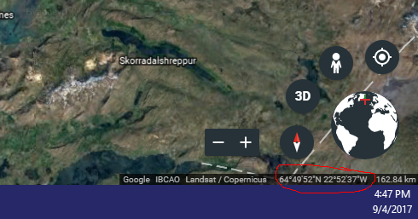
It looks like these numbers are for the exact center of my screen. If I zoom in on the spreading ridge, and in on the coast line, I should get accurate enough numbers to plug into that calculator I found.
- I will need to remember the units! And I will need to make sure that I get the units of the rate and the units of the distance into the same unit. I think Google should be able to convert everything for me.

QUESTION 6. According to someone online; how fast is the Atlantic crust growing? (No credit will be given if you do not provide information on where you found this information!) (1 pts)

QUESTION 7. Where is the longest stretch of seafloor from coast to spreading ridge in the Atlantic? Please give me your coordinates. (2 pts)

QUESTION 8. What is the total distance between your two coordinates? (for this answer you can use an online tool, or calculate it by hand, but for full credit you must show your calculations and/or sources.) (2 pts)

QUESTION 9. How old do you estimate the Atlantic oceanic crust to be? You must show me some Math. Questions 6 and 8 are needed for your calculation. (4 pts)

QUESTION 10. Compare your estimate to an estimate for how old the oldest Atlantic crust is to the answer of another Earth scientist (but not one in one of my classes!). (No credit will be given if you do not provide information on where you found this information!) (2 pts)

LINK 5: https://earth.google.com/web/@45.10547337,-127.55749855,110.39038119a,1587935.00074312d,35y,-0h,0t,0r/data=CoUBGoIBEnwKJTB4NDhkNjgwZGU2MTliNzg2MToweGY4ZjQ1OWI5YjhiOTQxOGUZJCMMqFwQUEAhFltS_2ohNcAqQVRlY3RvbmljIFBsYXRlcywgR2VvdGhlcm1hbCBFbmVyZ3kgUGxhbnQsIEJpZ2dlc3QgbGFrZSBJbiBJY2VsYW5kGAEgAQ

QUESTION 11. Looking at LINK 5, what kind of features can you see? (2 pts)

QUESTION 12. Describe the tectonic processes happening in LINK 5, and how it relates to what you can see on the map. You must include a drawing of some kind explaining what you think is happening. I recommend answers around 4 to 6 sentences. (5 pts)

LINK 6: https://earth.google.com/web/@-20.91860958,14.05769787,282.9644219a,22997.02323942d,35y,-0h,0t,0r
What are we looking at here!? (We are in Africa now)

You might have a better idea if you enter “3D” mode:
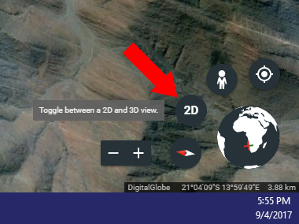
Hold “Shift” and “L mouse button” to wiggle yourself N, S, E, W.
Hold “Ctrl” and “L mouse button” to turn your head

QUESTION 13. In LINK 6 what kind of rocks do these appear to be in LINK 6? (1 pts)

QUESTION 14. Explain your reasoning for why you think they are that kind of rock? (2 pts)

Now just a short distance away
LINK 7: https://earth.google.com/web/@-21.42830992,14.20974372,438.25579761a,51577.77566174d,35y,8.02303122h,8.69142779t,-0r

QUESTION 15. In LINK 7 what kind of rocks do these appear to be? (Hint, they are a different class of rock) (1 pts)

QUESTION 16. Explain your reasoning for why you think they are that kind of rock? (2 pts)

Google Earth Engine
Welcome to the age of BIG data, machine learning, high powered web resources, and an amazing amount of information sharing. I think you will have a better idea of what I mean after this section.

Head to Google’s Earth Engine: https://earthengine.google.com/
The majority of the Earth Engine’s features and power is only accessible for companies and researchers who pay a fee to take full advantage of powerful google computers, machine learning and the full huge data sets. However there are still some fun free features to explore.

Google Earth Engine describes itself as a multi-petabyte catalog of satellite imagery and geospatial data. A byte is a small unit of computer data (consisting of a total of 8 numbers, which are either 0 or 1).
QUESTION 17. How many bytes are in a petabyte? (0.5 pts)

QUESTION 18. How many bytes are in an e-mail? (Obviously this will depend on how big an e-mail is, but just find out how big any one e-mail is as an example) (0.5 pts)

QUESTION 19. If we take a guess that google earth engine has 8 Petabytes, how many e-mails would you need to equal the same number of bytes? (2 pts)

Scroll down the earth engine landing page until you see a button to take you to TIMELAPSE.
I recommend changing the speed to slow, since it loads better, and you can notice the changes more easily.
In the search bar, type in Saddleback College, Mission Viejo, CA, United States

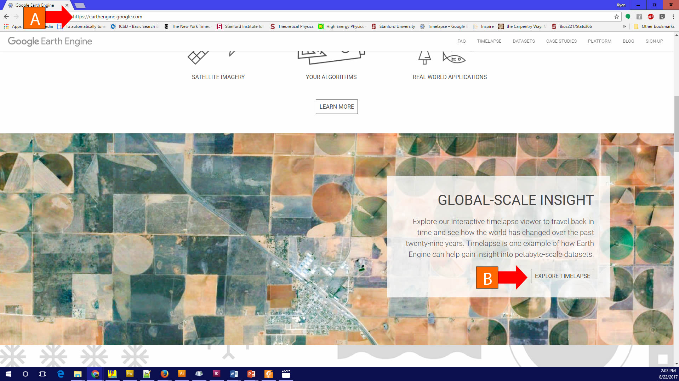

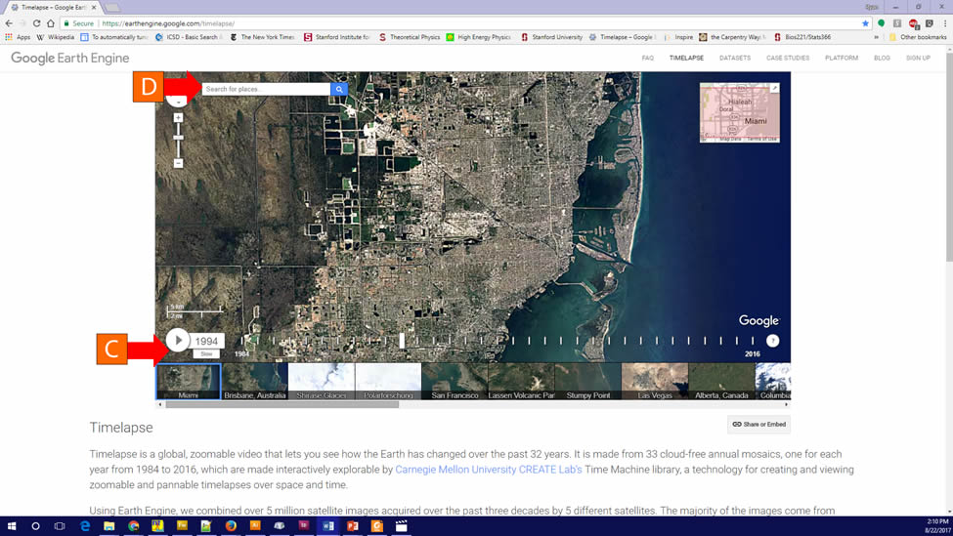

QUESTION 20. In the area around Saddleback Community College, what is the biggest change that you see happening from 1984 to 2016? (2 pts)

Search for “Salt Lake City Utah” and zoom out from the city so you can see the large salt lake near Salt Lake City.

QUESTION 21. During which year do you think the water levels change the most in the Great Salt Lake? (2 pts)

Notice the large dry lake bed to the left (west) of the Salt Lake. Memorize its light tan color. Next zoom out so you can see the western half of the United States.

QUESTION 22. Can you locate any other areas that have a similar color, and are their fore also likely dry lake beds? If there are 1 or 2 described in detail where they are located. If there are many, describe more generally where they can be found. (4 pts)

In the full Earth Engine, users can select by color (just like we did visually with the dry lakebed) and train the computer (using machine learning) to locate and measure all the area that has similar characteristic. You can even select for changes, telling the Earth Engine to locate in how many places on Earth there was water in 2010 but that water had dried up by 2016. The Earth Engine can also “see” more than we can, for example, our eyes have trouble telling apart clouds from snow, but to the Earth Engine, these two look very different.

Earth Engine Workspace
Head to the earth engine workspace at this link:
https://explorer.earthengine.google.com/#workspace

Click “Add data”
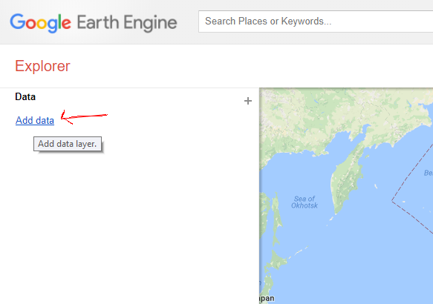Click “Surface_reflectance” to sort them, and then click “Add to workspace” on “MYD09Q1.005 Surface Reflectance 8-Day L3 Global 250m”
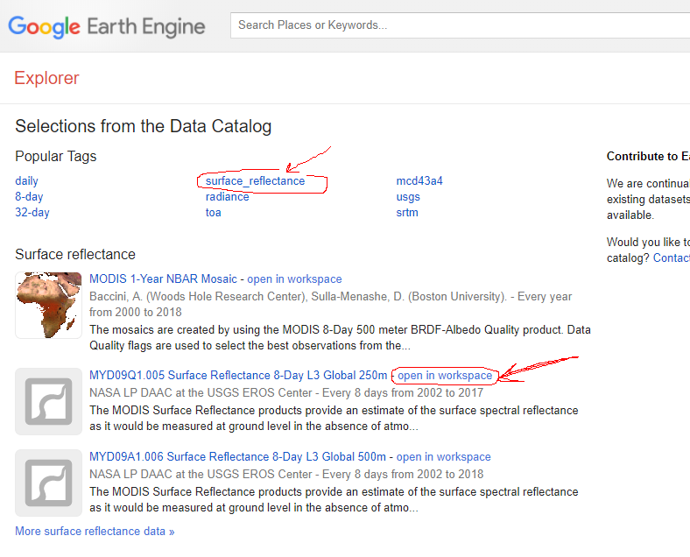
In the earth engine explorer we need to put in the following settings:
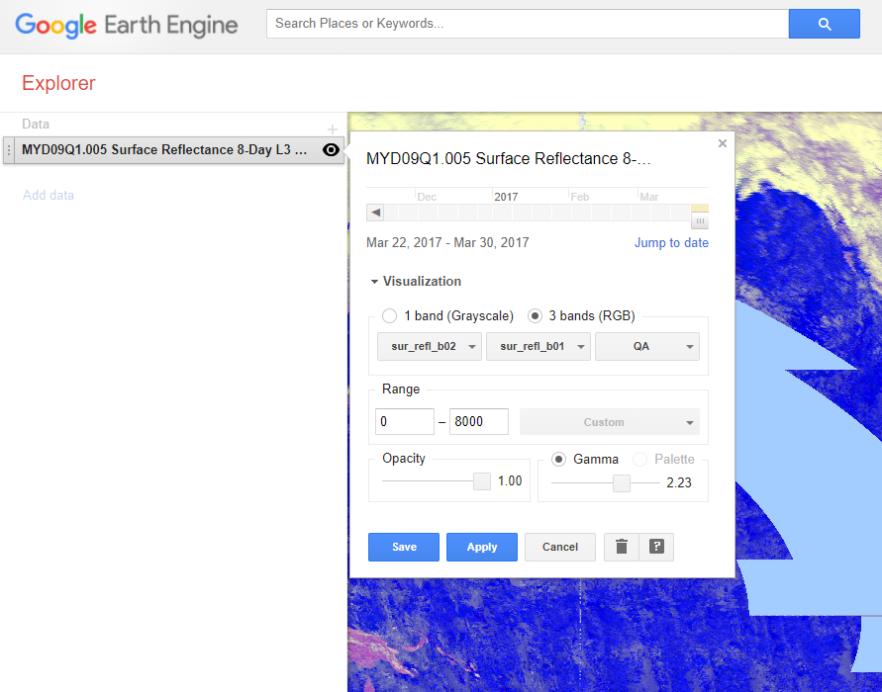
Set it to 3 bands (RGB)
Set “Surface refl b02” in the first box, “Surface refl_b01” in the second, and “QA” in the third.
Set the range to 100 to 8000
Set Opacity to 1 (it should start there)
Set Gamma to 1 or as close as you can get to this value (It should start there)
Click the blue “Apply”

The map should have blue pink-purple areas and yellowish areas. Yellowish areas are typically mineral surfaces reflecting light (so exposed minerals) Redish areas are plant leaves reflecting light, and blue areas are water surfaces reflecting light; all of this is being observed from a satellite.

QUESTION 23 Take a look at the Nile River in Egypt, and the surrounding desert. Notice how the rich lands around the Nile have the reddish color that indicates plants. Can you locate any plant life out in the Sahara desert? If so, describe its location, or take a screenshot and paste it in here. (4 pts)

QUESTION 24. Using Google Earth in the 3D viewer, or Google Earth Engine in time-lapse, locate something in our world you find interesting. If using Google Earth, include the link, if using Google Earth Engine, explain to me what to search for and how to find it. Tell me why it is interesting to you! (3 pts)

